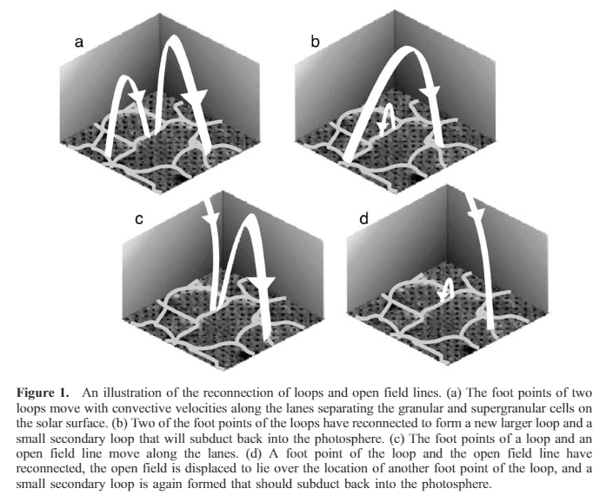

In Fisk et al, 2003, they pose a theory for how the energy for solar winds are created. Figure 1 above shows the process by which loops and field lines connect. Each loop has two foot points, and when the foot points of two different loops have opposite polarity, these foot points connect to form one big loop, as seen in figures 1a and 1b. A smaller loop is also formed where the loops connect, and the flux in this loop goes back into the photosphere. As the primary loop grows bigger, it can encounter an open field line, and if they have opposite polarity, they can also connect with each other, as seen in 1c and 1d. Then the material that was originally in the closed field loop is transported into the open field lines. The open line is displaced by all this reconnecting, which alters the magnetic field, allowing more energy to enter the corona.

Take an area *d***s**, with an open field line and a loop’s foot point that have the same polarity. They won’t reconnect, and *d***s** has the flux from one open field line passing through it. The other end of the loop can connect with a different open field line, creating a new open field line that will align with the first open field line. This doubles the amount of flux through *d***s**. The strength of the magnetic field along the line will also double, from **B**open to 2**B**open. The equation for the energy is Emagnetic=**.** As the volume increases, the flux stays constant, so 2 $∫B⋅ⅆh$ goes to $∫B⋅ⅆh$**.** This releases energy into the corona and serves to accelerate the solar wind.

Fisk et al, 1999 describes that as the field lines keep changing and moving around, the amount of flux in some areas will increase by $δB$ and decrease by $δB$ elsewhere, so the total magnetic flux doesn’t change, but the density does, by $\frac{δB^{2}}{8π}$. The changes in one area will propagate elsewhere, but the propagation can’t go on forever, so the energy does work on the plasma, heating the corona and allowing for the acceleration of the solar wind.

Fisk et all, 1999: <https://agupubs.onlinelibrary.wiley.com/doi/epdf/10.1029/1999JA900256>

Figure 1: Fisk, L. A. “Acceleration of the Solar Wind as a Result of the Reconnection of Open Magnetic Flux with Coronal Loops.” *Journal of Geophysical Research*, vol. 108, no. A4, 19 Apr. 2003, doi:10.1029/2002ja009284.